IT13: ADBMS
Chapter 2:SQL
Practical Assignment 1 Solution Template
Name – Manali Vijay Barge
Roll no: 2601012

Practical 1. Implementation of DDL & DML commands in SQL with suitable examples
Create the following tables. (Primary Keys are underlined)
Employee ( emp_id ,emp_name, City, bdate)
Investor ( inv_no, inv_name, inv_date, inv_amt, emp_id)
Create a Primary key constraint on emp_id in the Employee table and inv_no in the Investor table.
Write the SQL query and paste a screenshot of the output below the question.
- Create a database and two tables in it.
Create database Practical1;
use Practical1;

CREATE TABLE Employee (
emp_id INT PRIMARY KEY,
emp_name VARCHAR(50),
City VARCHAR(50),
bdate DATE
);
desc Employee;

CREATE TABLE Investor (
inv_no INT PRIMARY KEY,
inv_name VARCHAR(50),
inv_date DATE,
inv_amt DECIMAL(10,2),
emp_id INT
);
desc Investor;
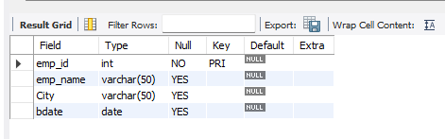
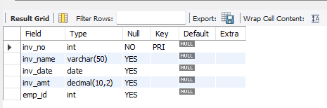
- Insert at least 5 rows into the table.
INSERT INTO Employee (emp_id, emp_name, City, bdate)
VALUES(1, 'Amit', 'Pune', '2002-05-12'),
(2, 'Sneha', 'Mumbai', '2001-08-20'),
(3, 'Rahul', 'Satara', '2000-03-15'),
(4, 'Priya', 'Nashik', '2002-11-25'),
(5, 'Neha', 'Kolhapur', '2001-01-10');
Select * from Employee;

INSERT INTO Investor (inv_no, inv_name, inv_date, inv_amt, emp_id)
VALUES (101, 'ABC Ltd', '2026-01-10', 25000.00, 1),
(102, 'XYZ Ltd', '2026-02-15', 30000.00, 2),
(103, 'PQR Ltd', '2026-03-20', 15000.00, 3),
(104, 'LMN Ltd', '2026-04-05', 40000.00, 4),
(105, 'DEF Ltd', '2026-05-12', 20000.00, 5);
Select * from Investor;

- Display all the information in the Employee table.
Select * from Employee;
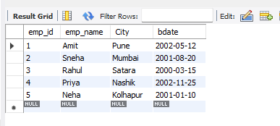
- Add columns ‘Age’ and ‘Salary’ to the Employee table; apply check constraints for (Age<=50 and Salary>=10000).
ALTER TABLE Employee
ADD Age INT,
ADD Salary DECIMAL(10,2),
ADD CONSTRAINT chk_emp_age CHECK (Age <= 50),
ADD CONSTRAINT chk_emp_salary CHECK (Salary >= 10000);
Select * from Employee;
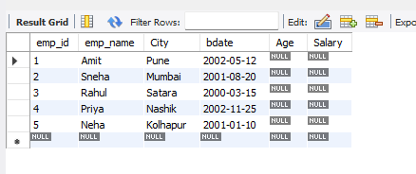
- Add a column ‘Age’ to the Investor table.
ALTER TABLE Investor
ADD Age INT;
desc Investor;
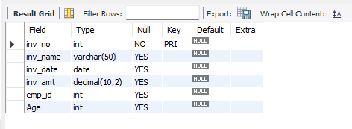
- Change the data type of inv_name from varchar to text in the Investor table
ALTER TABLE Investor
MODIFY COLUMN inv_name TEXT;
desc Investor;
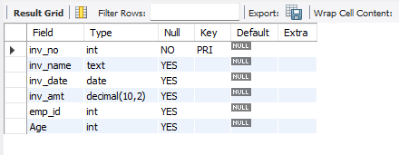
- Change the name of the column/field Emp_id to E_id.
ALTER TABLE Employee
RENAME COLUMN emp_id TO E_id;
desc Employee;
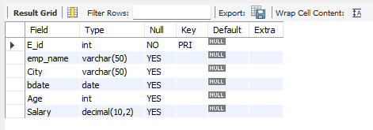

- Update the city of Emp_id-4 to the current city, Nagpur.
UPDATE Employee
SET City = 'Nagpur'
WHERE E_id = 4;
Select * from Employee;
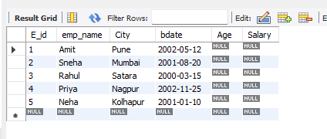
- Delete one record from the Investor table.
DELETE FROM Investor
WHERE inv_no = 105;
Select * from Investor;
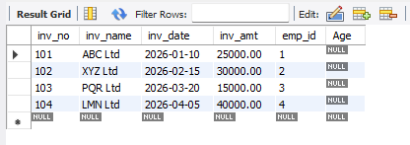
- Drop the column ‘Age’ from the Investor table.
ALTER TABLE Investor
DROP COLUMN Age;
Desc Investor;

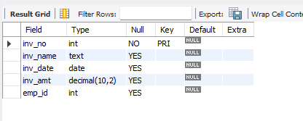
- Drop the CHECK constraint on the ‘Age’ column from the Employee table.
ALTER TABLE Employee
DROP CHECK chk_emp_age;
SHOW CREATE TABLE Employee;
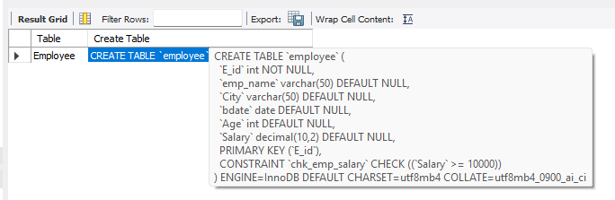
- Create foreign key constraints between the Employee and Investor tables
ALTER TABLE Investor
ADD CONSTRAINT fk_investor_employee
FOREIGN KEY (emp_id)
REFERENCES Employee(E_id);
Desc Investor;

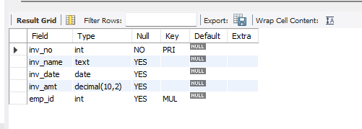
- Display any 4 columns from the Investor table.
SELECT inv_no, inv_name, inv_date, inv_amt
FROM Investor;
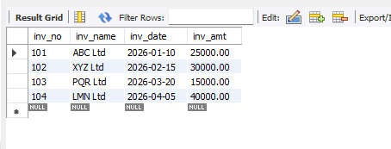
- Rename a table.
RENAME TABLE Investor
TO Investor_info;
Show Tables;
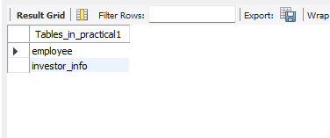
- Delete all the records using the TRUNCATE command.

ALTER TABLE Investor_info
DROP FOREIGN KEY fk_investor_employee;
TRUNCATE TABLE Investor_info;
TRUNCATE TABLE Employee;
SELECT * FROM Investor_info;
SELECT * FROM Employee;
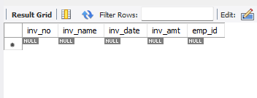
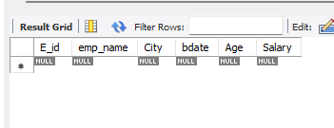
- Drop both tables from the database.
DROP TABLE Investor_info;
DROP TABLE Employee;
Show TABLES;
